**Information Technology Service Management System**

**Abuzar Shaikh1, Shivam Tiwari2, Needa Shaikh3, Zainab Pirani4**

Student, Department of Computer Engineering, M.H. Saboo Siddik College of Engineering, Mumbai, India 1-3

Head of Department, Department of Computer Engineering, M.H. Saboo Siddik College of Engineering 4

**Abstract**: ITSM (Information Technology Service Management System) is a Cloud-Based Web App that is designed to handle the workflow of various IT projects that are undertaken in an organization. The workflow includes the commencement of the idea of the project from the Business Department to the Central Technical Surveillance Department, which monitors the entire workflow, and the IT Department which is responsible for the development of the project. There are various stages from the Initialization of the project, Documentation, and Validation. The Validation stages are further divided into various sub-stages where the idea is presented to each department for assessment and for providing a rough estimation of the cost that would be incurred while working on the project. The members of various Departments may hold meetings to discuss and to infer upon the changes or modifications that are necessary to incorporate in the project. The Web App aims to serve as a platform where the information can be stored, and shared centrally, to ensure a smooth workflow.

Keywords: cloud-based, Documentation, Validation, IT, Surveillance

1. **Introduction**

“The Airline Group” or “TAG” is a consortium owning a group of airlines in Europe. The company has around 50,000 employees across the airline is up. TAG has its own IT division with its branding – “TAG tech”. “TAG tech” handles all the IT operations across the airline group.

TAG tech has 3 major functions:

* Managing Business-As-Usual (BAU) operations of the various applications running on its infrastructure
* Track and fix issues and bugs
* Programs / Projects to align with the company’s strategy/vision
  1. *Managing Business – As – Usual (BAU) operations*

The functioning of business applications that support day to day operations is critical to the very existence of the organization. They are also called business-critical applications. The IT infrastructure (servers, networks, support, etc) are the backbone of these applications. This function tools/agents the existing IT infrastructure can support the optimal running of these applications. This function can include application end users, helpdesk support teams, application maintenance teams, monitoring tools/agents.

* 1. *Track and fix issues/bugs*

IT systems (hardware/software) need to have efficient issue tracking and fixing mechanisms to ensure business continuity. This function continually monitors bugs/issues reported by the users or system monitoring tools and tracks them to completion/issue resolution. The organization has employed ample resources to ensure any issues in its business-critical systems are promptly investigated and fixed.

* 1. *Deliver Programs / Projects to align with the company’s strategy/vision*

Every organization needs to keep up with the changing market conditions and rapid technological advancement. To cater to this, TAG tech has this major function of initiating, managing, and delivering software projects that would keep the organization aligned to its mission statement as well as keep up with the market trends and latest technologies. TAG tech implements the PRINCE2 & Agile project management methodology to manage its portfolio.

The ITSM (Information Technology Service Management) system ensures that it caters to all the needs that are required by “TAG - Tech”.

1. **Related Works**

[1] In this research paper focuses upon why strategic IT planning is required in an IT organization and how a Management system helps to achieve that. The company or organization must consider building and implementing a clear Information Technology Service Management (ITSM) that can control all IT services better. The paper explains us the various models and the dependent frameworks that are present and will be useful for an ITSM implementation.

[2] The purpose of this paper is to examine how knowledge application capability effectiveness (KACE) in ITSM can be affected through several knowledge management processes. In ITSM, IT service desk function deals with various IT problems and incidents daily through utilization of all available knowledge resources (i.e., organizational knowledge and personal knowledge). A framework was developed to identify factors that affect KACE in IT service desk function. The framework focuses upon socialization, externalization, internalization, and combination as contributors to the formation of KACE. The results are founded upon qualitative data in which manual and computer-aided content analysis were undertaken.

[3] This article helps us explores the various ITSM that are adopted by various companies worldwide between 2010 - 2018. It finds that not all   ITSM practices are uniformly adopted, and some processes tend to be adopted more widely than others. The review also discusses the various measurement models that can be used for validation of an ITSM model or Framework.

[4] This research addressed the problems of the lack of transparency and the need for efficiency in ITSM process assessment. Using the Design Science Research methodology, it developed an innovative Software-mediated Process Assessment (SMPA) approach that automates assessment of ITSM processes and supports the decision-making of IT Service Managers. It implemented a decision support system (DSS) to automate the SMPA approach and evaluated it at two IT service providers. The evaluations indicated that the SMPA approach supports decision-making on process improvements.

[5] This paper presents the results based on a study of comprehensive review of publications in ITSM from 2000 to 2010. A total of 152 research papers from leading information systems (IS) journals and conference proceedings were identified, categorized, and analysed from the perspectives of reference discipline, theoretical foundation, research method, level of analysis, and research topic. The findings suggested five primary conclusions: 1) lack of theoretically driven researches; 2) the field is still improving 3) ITSM performance issues, justifications, and IT Infrastructure Library (ITIL) are popular topics of research; 4) ITSM researchers do not seem to consider research at an individual level; 5) the most popular research method was the conceptual orientation. Recommendations for future research in ITSM are presented and articulated.

[6] This research examines the IT Service Management (ITSM) research literature, starting from passed up to the present. The applied research method is the literature review, in which a search is conducted across 8 major global, regional, and national conferences as well as 71 international journals. To classify the results, a morphological box is used. Moreover, a keyword analysis is conducted to obtain an overview about research topics. This paper shows which areas and topics are explored, and which are underexplored. A research agenda was proposed to handle the identified areas of future research.

[7] This paper focuses on the implementation of an ITSM in IT Infrastructure Library (ITIL) Framework. ITIL is the most widely used IT service management framework. It consists of best practices that can be used in implementing, for example service support processes, such as incident management and problem management.

1. **System Architecture.**

The Front Door Request (FDR) is the core driving force of the ITSM framework. Each user according to their specific roles and access levels edit, reviews, approves it. The FDR life cycle serves as the most important part of the entire application workflow. The cycle begins with the initiation of the FDR, passing it to the various users of the systems and moving from one stage to another. Each FDR is mapped to a Proposal Lead, Project Manager, and the respective IT Infrastructure representatives. The following use case diagram show cases the users of the ITSM.

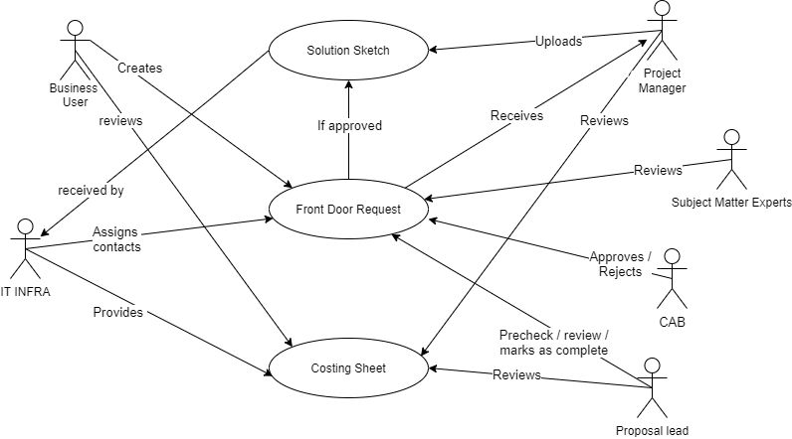

**Figure 1: Use Case Diagram**

* 1. *Technology Stack*

This system is created for the users of “TAG Tech” and the Airlines present in the TAG consortium. It

is a cloud based Web App which is responsive and can be easily accessible by mobiles or personal computer. The application would be expected to have a high user traffic and needs to be robust and scalable for handling it. Django which is a framework written in Python along with MongoDB to make it extremely fast and bootstrap as the front end for making the application responsive.

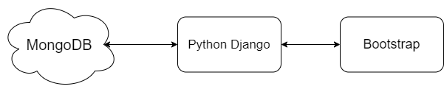

**Figure 2: Technology Stack**

MongoDB due to its ability to store huge volumes of data and can be used as an excellent distributed database was the ideal choice, as the web application would be connected to companies very own data centres to keep the integrity of their company.

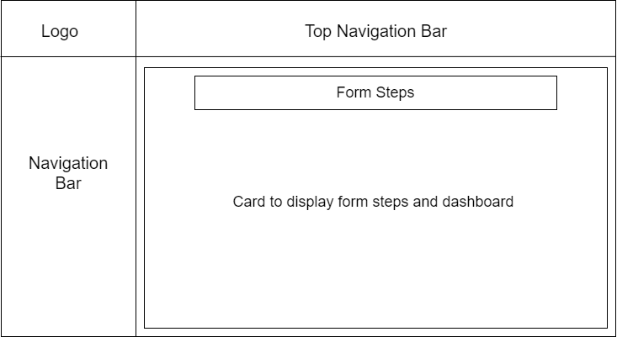

**Figure 3: Interface Design**

* 1. *Design*

The user interface has been designed in such a way that it is easy to understand it briefly and aesthetically pleasing at the same time. The layout is quite simple with the focus on the form itself as shown in Figure 3. There are two navigation bars, one at the top and the other on the left side. The top navigation bar provides quick links to profile switching and searching, while the navigation bar on the left side contains the different trackers for the projects, which are displayed according to the user designation. The form is displayed on a card that helps in keeping it separate from other UI elements. The dashboard displays the list of all the FDR of the projects that have been undertaken along with their statuses. This makes it easier to view any project’s FDR and also one can simply click on it to view the FDR as well as the corresponding solution sketch and statement of work associated with it.

1. 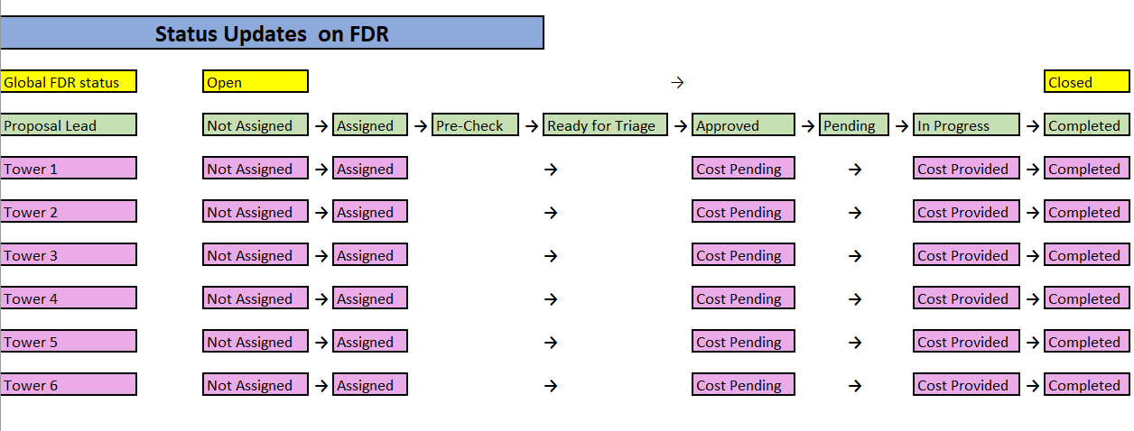**Implementation**

**Figure 4: Steps of the FDR**

The proposed system aims to make use of principles of the traditional approach and provide a more simple, centralized, and automated approach. Thus, reducing various factors such as data redundancy, inefficient communication and human based error. For understanding the system, we can divide it into various modules and understand them.

* 1. *Data Flow*

The entire process starts by the creation of the Front Door Request (FDR). Following are the stages of the system

1. Creation of FDR: The FDR is created by the business user of the system, it can be created with two types, a statement of work and solution sketch. A business user comes up with an idea and creates the FDR with details like the project title, description, company, categories etc.
2. Assigning a Proposal Lead and Project Manager: Once the FDR is created by the Business User a project manager and proposal lead are assigned to an FDR. These entities are actively engaged throughout the FDR lifecycle. Both project manager as well as the proposal lead perform precheck and pass it on to the IT Infra team.
3. Assignment of IT Infra Representatives: Once the FDR gets the above two entities assigned to it. It moves on for further assessment and is received by the SME’s (Subject Matter Experts) of the IT Infra group. These SME’s assign individuals from each towers respective FDR’s.
4. Providing Costing: The IT Infra group which consists of 6 Towers provide the costing in the respective costing sheets, once the costing is provided by each tower heads, the FDR goes to the PL for review.
5. Reviewing: Once the costing for the FDR is provided it is reviewed by the Proposal Lead and in case of any discrepancies, the PL resends the costing sheet to the IT Infra team for further additions or improvement.
6. Completion and Approval: Once the review is successful the FDR is approved and passed on to the PM Team.
7. **Application Design**

The Login Page is the first page or the landing page of the web application.

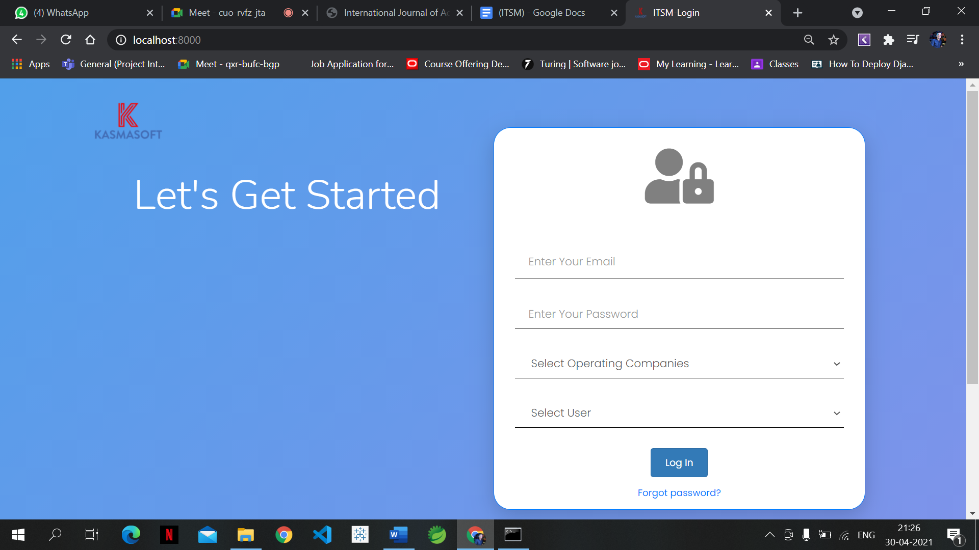

**Figure 5: Login Page**

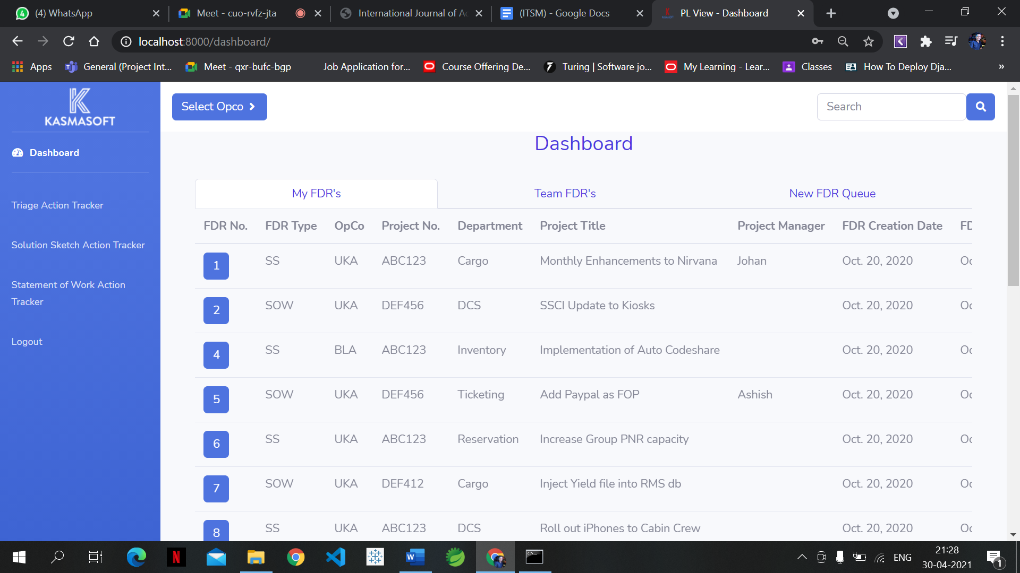

**Figure 6: Dashboard**

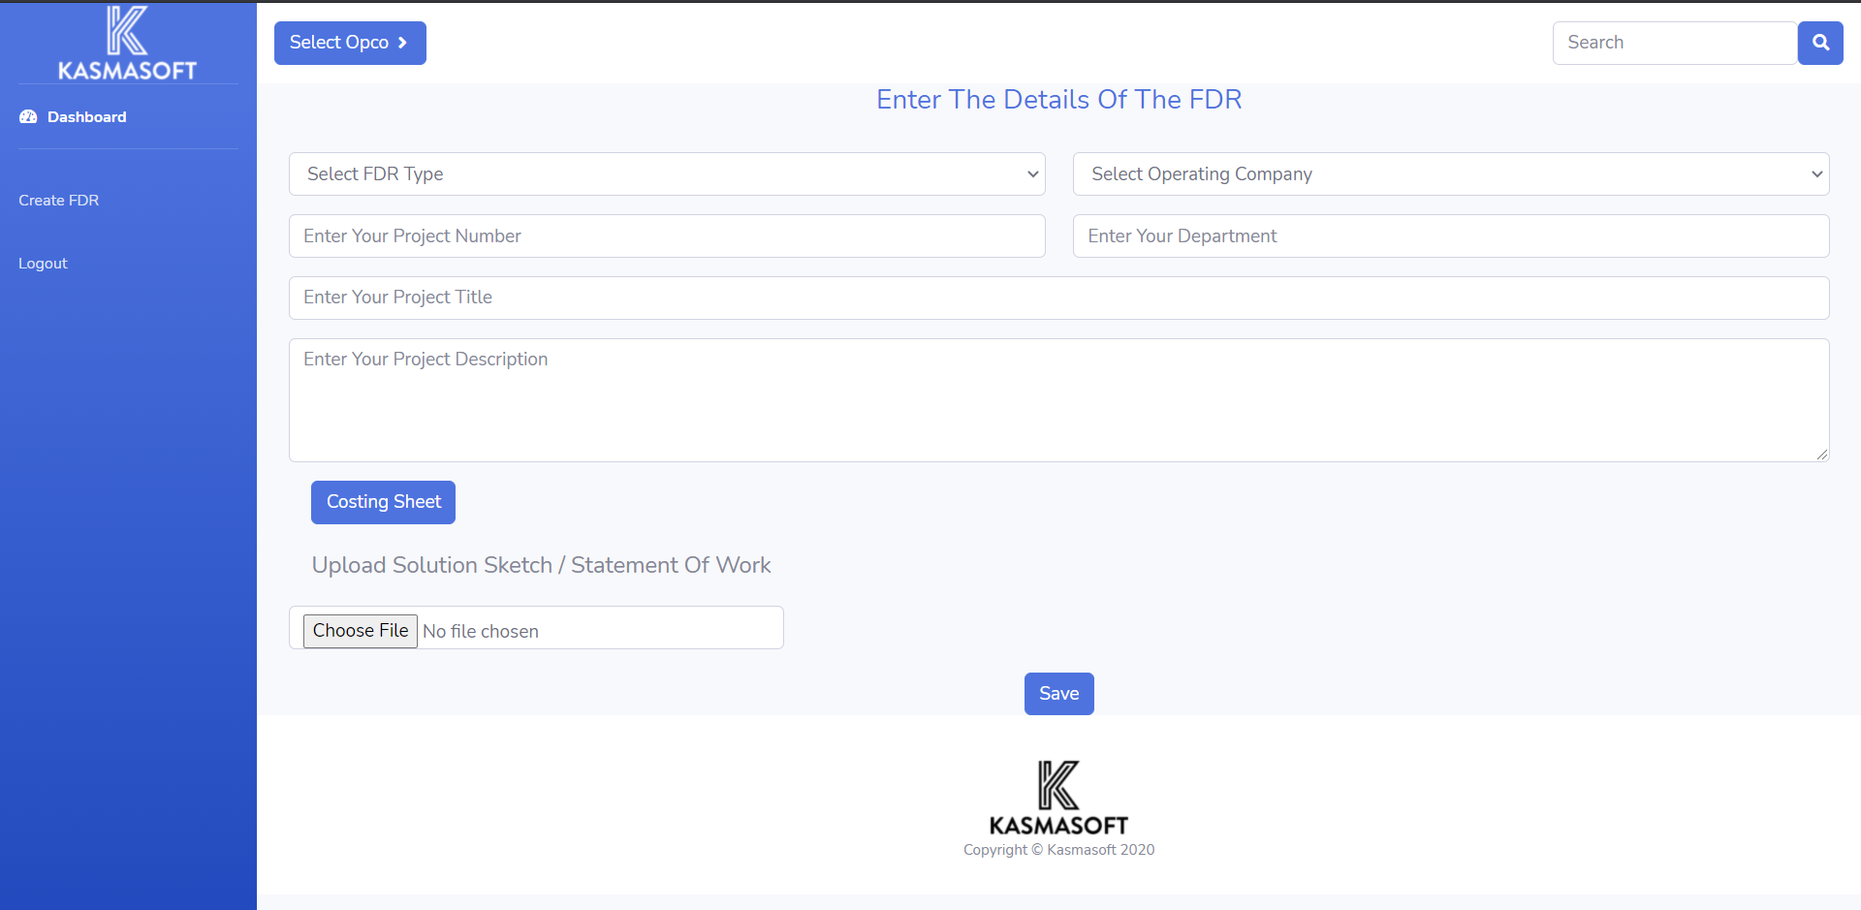

**Figure 7: Creation of FDR**

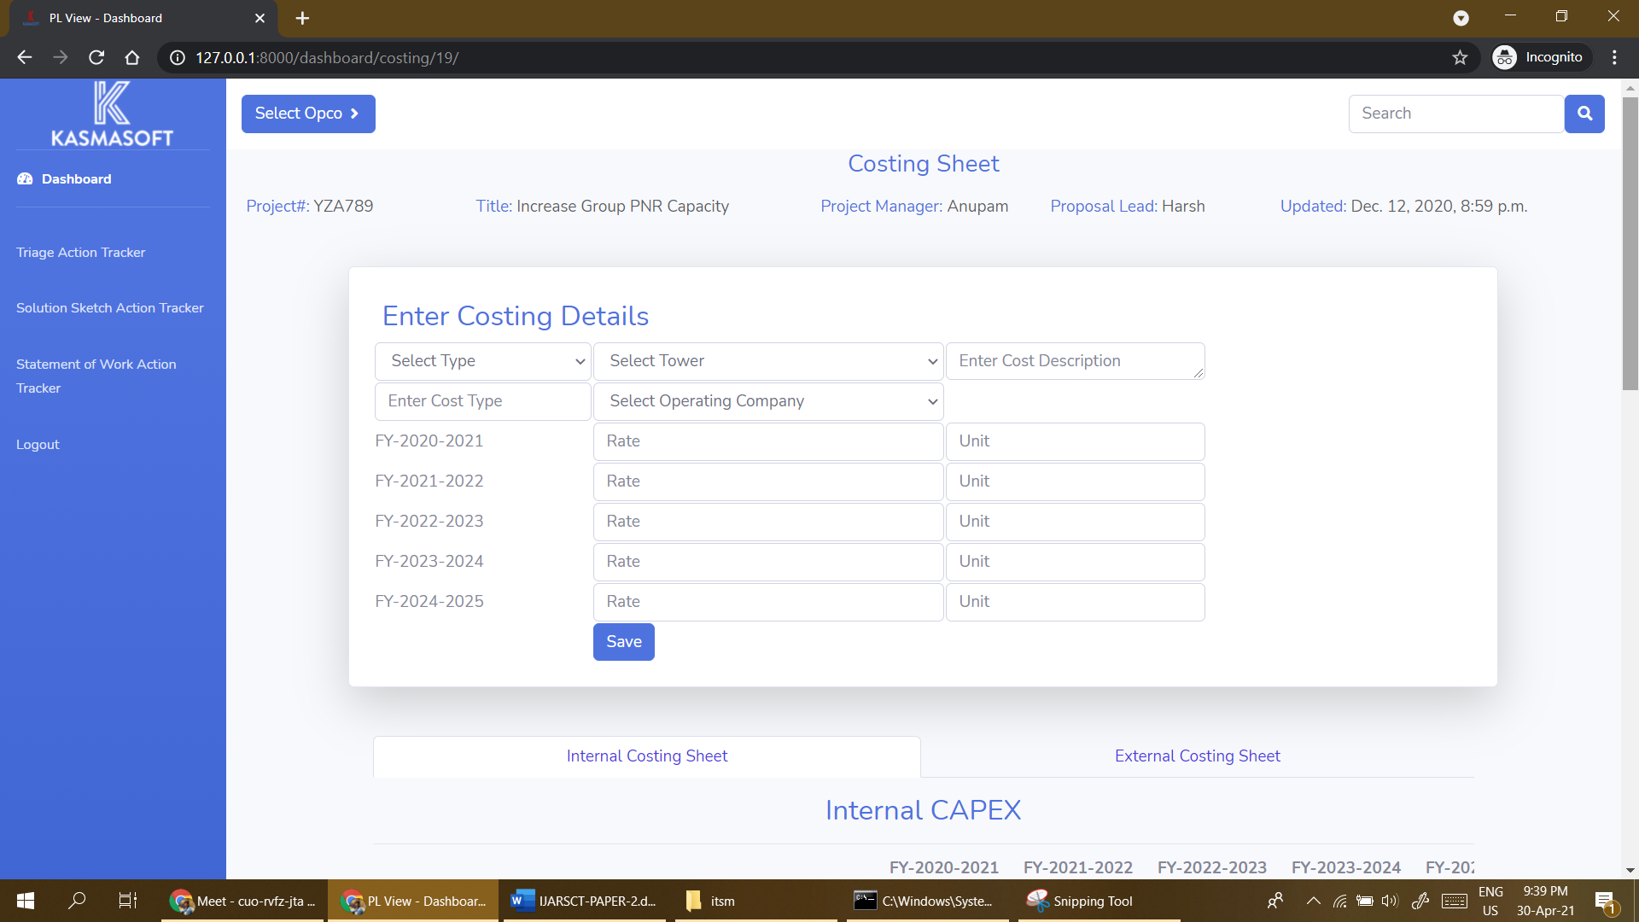

**Figure 8: Costing Sheet**

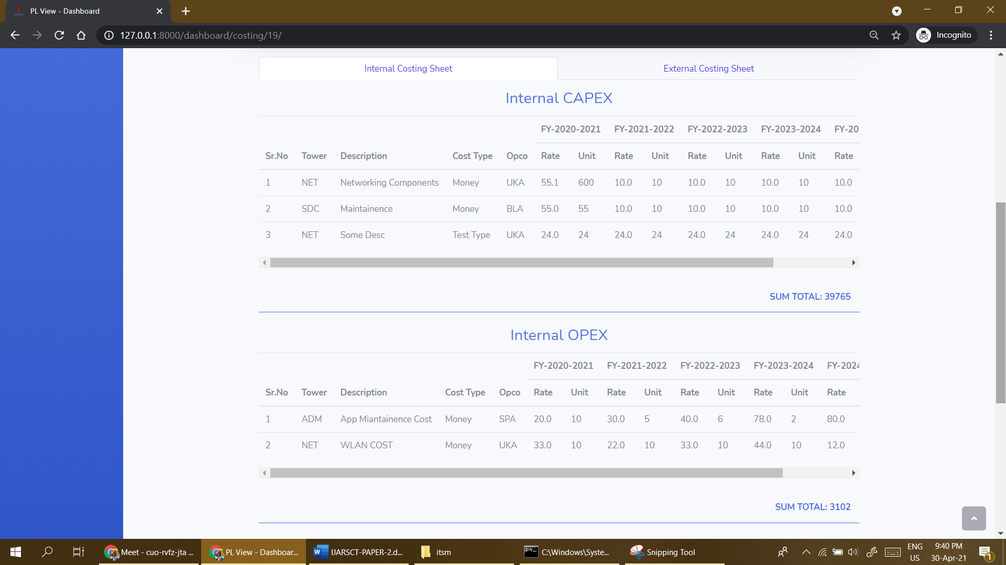

**Figure 9: Internal Costing Sheet -1**

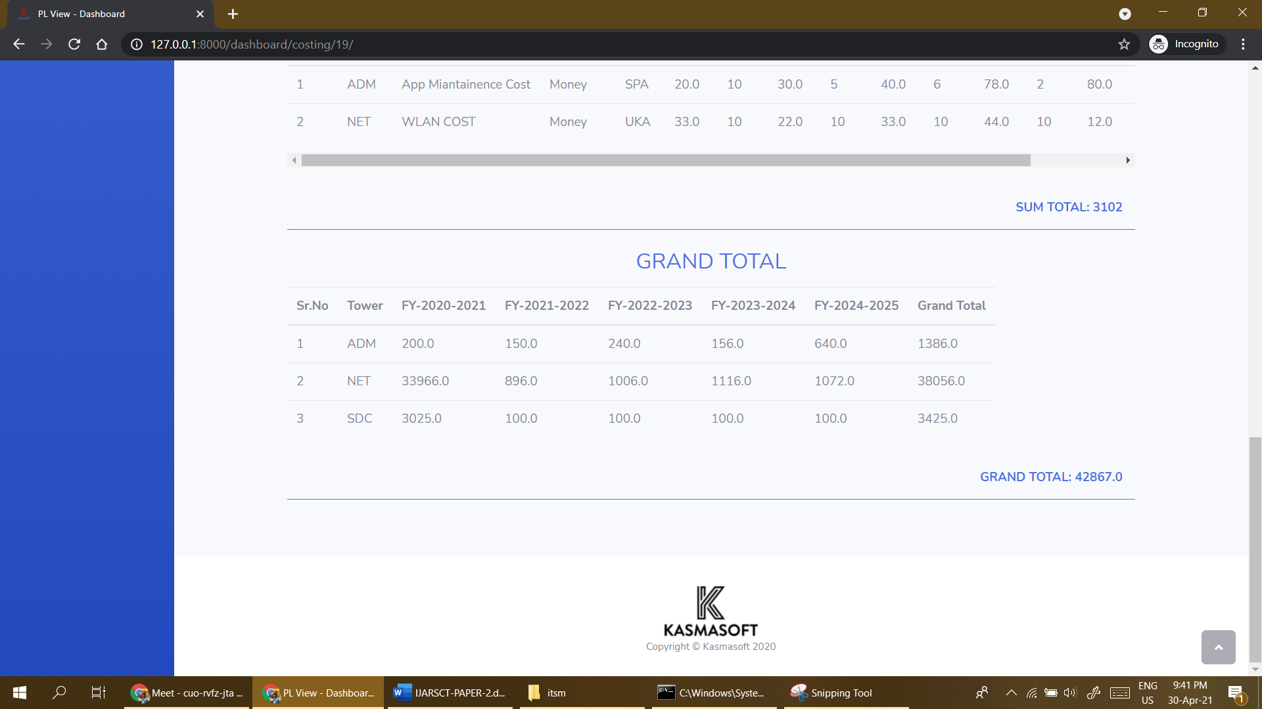

**Figure 10: Internal Costing Sheet -2**

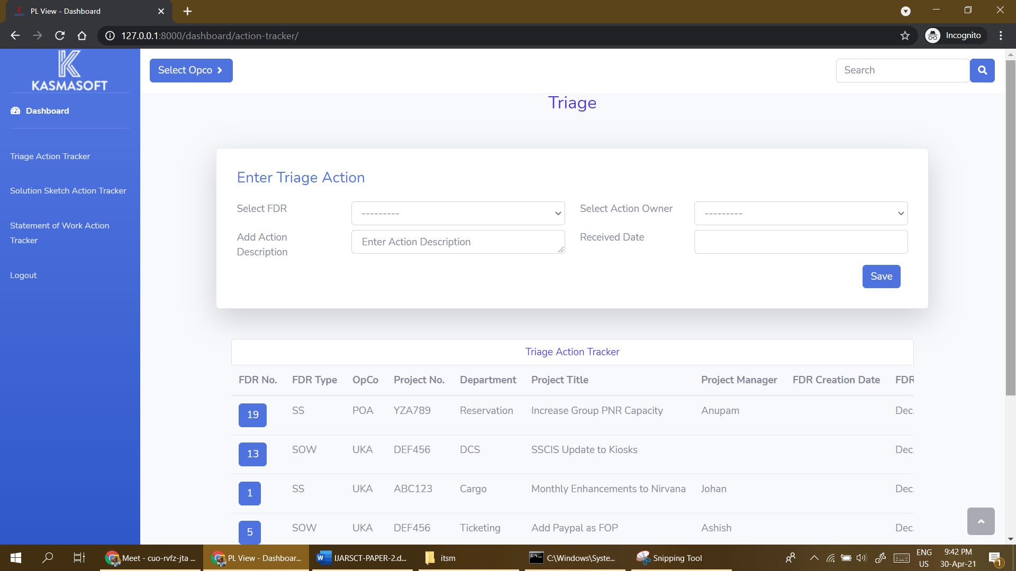

**Figure 11: Triage Action Tracker**

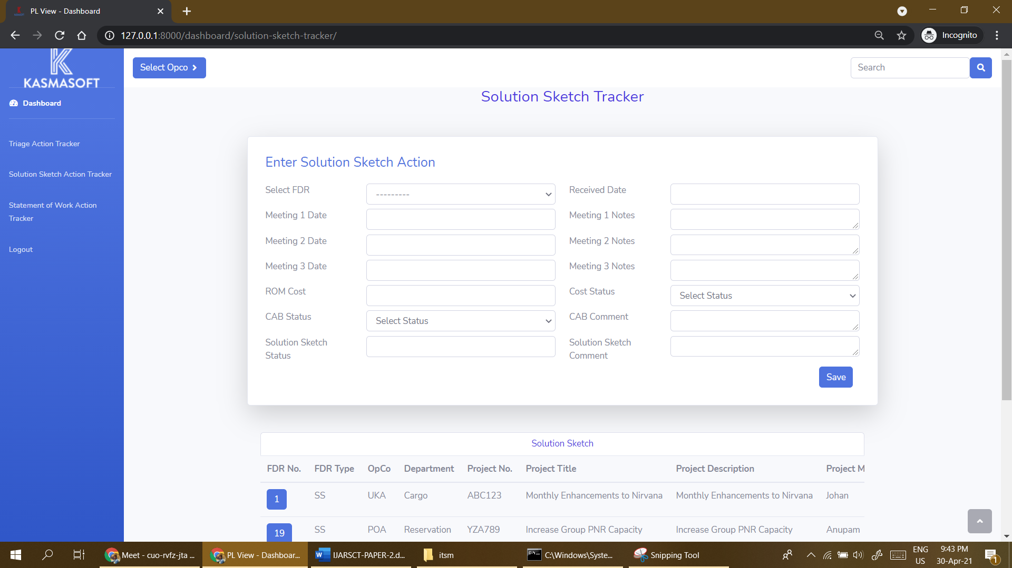

**Figure 12: Solution Sketch Tracker**

1. **Conclusion:**

We summarized the entire workflow of the functioning of the application and started implementing modules required throughout the application such as the account for logging into the system, the dashboard for displaying tables that are fetched from the database, and action trackers for tracking of progress during projects registered into the application. We have implemented the tasks of assigning the Project Manager and Proposal Lead for the FDR received for a particular project. The Action Tracker, Solution Sketch, and Statement of Work are also built where meeting notes, FDR creation date, and FDR received dates are stored.

**Acknowledgement**

We wish to express our sincere thanks to our director Dr. Mohiuddin Ahmed and our principal Dr. Ganesh Kame, M. H. Saboo Siddik College of Engineering for providing us all the facilities, support and wonderful environment to meet our project requirements. We would also take the opportunity to express our humble gratitude to our Head of Department of Computer Engineering Dr. Zainab Pirani for supporting us in all aspects and for encouraging us with her valuable suggestions to make our project successful.

We are highly thankful to our internal project guides Dr. Zainab Pirani whose valuable guidance helped us understand the project better, their constant guidance and willingness to share their vast knowledge made us understand this project and its manifestations in great depths and helped us to complete the project successfully.

We would also like to acknowledge with much appreciation the role of staff of the Computer Department, especially the Laboratory staff, who gave the permission to use the labs when needed and the necessary material to complete the project. We would like to express our gratitude and appreciate the guidance given by other supervisors and project guides, their comments and tips helped us in improving our presentation skills. Although there may be many who remain unacknowledged in this humble note of appreciation but there are none who remain unappreciated.

**REFERENCES**

[1]  Hendro Gunawan : Strategic Management for IT Services Using the  Information Technology Infrastructure Library  (ITIL) Framework, 2019

[2] Abdulazeez Ftahi,  Abdul Hafeez-Baig, Raj Gururajan : Towards Effective Knowledge Application Capability in ITSM through  Socialisation, Externalisation, Internalisation and Combination,2019.

[3]Vipul Jain, O. P. Wali and V. Raveendra Saradhi **:** Information Technology Service Management [ITSM] Research:  A Literature Review of Practices, Solutions and Measurement, 2018

[4] Anup Shrestha, Aileen Cater-Steel & Mark Toleman **:** Innovative decision support for IT service management, 2016.

[5] Narges Shahsavarani,Shaobo Ji **:** Research in Information

Technology Service Management  (ITSM) (2000 – 2010) : An Overview**,** 2014.

[6] Thorsten Proehl, Koray Erek,Felix Limbach,Ruediger Zarnekow : Topics and Applied Theories in IT Service Management,2013.

[7] Antti Lahtela, Marko Jantti, Jukka Kaukola Tieto : Implementing an ITIL-based IT Service Management Measurement System,2010.